

**MARKETING DATA ANALYSIS OF THE COMPANY PUMA SE**



**APPLIED MARKETING ANALYTICS**

**SUBMITTED BY**

**CLINTS THEEYATTUPARAMBIL JOHN**

**STUDENT ID – 13518992**

**MODULE LEADER – SAMER SARSAM**

**TABLE OF CONTENTS**

**INTRODUCTION…………………………………………………………………………………………3**

**OVERVIEW AND SCOPE OF PUMA SE…………………………………………………………3**

**MARKETING DATA ANALYSIS ……………………………………………………………………6**

**SIMPLE LINEAR REGRESSION…………………………………………………………………….9**

**MULTIPLE REGRESSION…………………………………………………………………………….13**

**DISCUSSION AND EVALUATION OF THE OUTCOME…………………………………..13**

**CONCLUSION AND RECOMMENDATIONS…………………………………………………16**

**REFERENCES……………………………………………………………………………………………17**

**APENDIX………………………………………………………………………………………………..18**

**INTRODUCTION**

This study analyses the marketing information of PUMA SE by using linear regression analysis to determine how it affects the company's success. The findings, which are visually represented through tables and graphs, identify important variables. Conclusions and projected values are discussed, and actionable ideas for improvement are provided. Overall, this study strengthens PUMA SE's ability to analyse data and offers valuable insights for decision-making.

**OVERVIEW AND SCOPE OF PUMA**

PUMA SE commonly known as PUMA, is a worldwide company with headquarters in Germany that focuses on creating, producing, and selling sports and leisure footwear, clothing, and accessories. It is the third largest sportwear manufacturer in the world. Since its founding in 1948 by Rudolf Dassler in Herzogenaurach after a split with his brother, who went on to establish a competing sporting goods company called Adidas, PUMA has developed into one of the most recognisable sports companies in the world, known for its products that emphasise performance and a unique aesthetic. For its products and marketing strategies, the company has expanded into more than 130 different countries. (PUMA SE. (2023)).

To improve organisational performance, PUMA's marketing strategy focuses on a number of important aspects. Firstly, the brand's strong position as a sports brand, through partnerships with world-class athletes like Usain Bolt and Neymar Jr., as well as joint ventures with cultural and fashion heavyweights like Cara Delevingne and Dua Lipa, contributes to brand clout and appeal to consumers who follow trends. (PUMA SE. (2023)).

The company positions itself as a fashion-forward and athletically authentic brand that caters to the modern female consumer because it understands how important women are as both trendsetters and active participants in athletic activities. In order to maximise its impact on important retailers' commercial success, PUMA also places a strong emphasis on improving its distribution networks and establishing trustworthy alliances with them. (PUMA SE. (2023)).

Another critical component of PUMA's marketing strategy is its local relevance. Recognising the need for unique methods in various areas, the brand focuses on partnering with sports, ambassadors, influencers, collaborative partners, and communication channels that are relevant in each country. (PUMA SE. (2023)).

To strengthen its reputation as a sports brand in North America, PUMA is making a comeback in the basketball world. JAY-Z's appointment as the basketball division's creative director will help PUMA create a line of products that will appeal to consumers both on and off the court, further establishing the brand's position in the industry. (PUMA SE. (2023)).

Figure 1 Global revenue of puma from 2000 to 2022 (in billion euros)

(Source: Statista, 2022)

Figure 1 shows an increasing trend in Puma's global revenue from 2000 through 2022, with a slight decrease during the pandemic. The business immediately recovered, yet, and revenue continued to rise after that.

Figure 2 Sales of the biggest athletic apparel, accessories, and footwear companies worldwide in 2022 (in million dollars)

(Source: Statista, 2022) Figure 2 shows that the company Puma SE is the third-biggest athletic apparel, accessories, and footwear company in the world after its competitors Nike and Adidas. With a revenue of approximately 7880 million dollars, Puma's financial performance demonstrates its ability to generate substantial sales and compete effectively with industry giants.

**MARKETING DATA ANALYSIS**

Figure 3 Sales and gross profit

The figure 3 represents the sales and gross profit of Puma SE over a period. The chart shows fluctuations in both sales and gross profit figures. From Q1 2012 to Q3 2018, there was a general upward trend in both metrics. However, after Q3 2018, both sales and gross profit figures stabilised around the range of 2000–3500 million euros, remaining relatively constant. This suggests a period of consistent performance for Puma SE over the period.

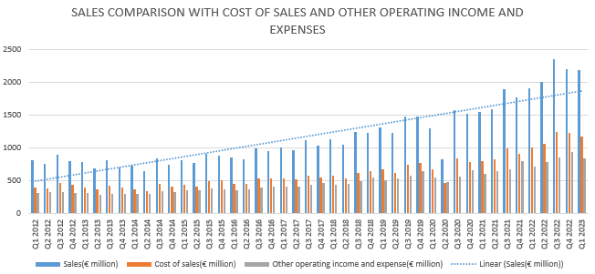

Figure 4 Sales comparison with its independent variables

The combination chart in the figure 4 shows that all the three variables are increasing throughout the year. As the cost of sales and other operating income and expenses increases, sales also increase, and vice versa. The sales show a fluctuating pattern, with intermittent increases and decreases. The comparison between sales, cost of sales, and other operating income and expenses would reveal the financial performance and profitability of the business throughout the mentioned period.

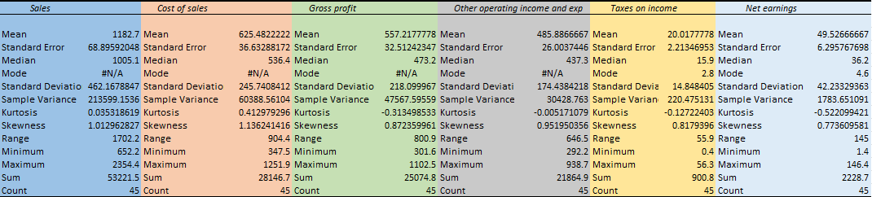

Table 1 Descriptive statistics

The table 1 presents descriptive statistics for various variables related to Puma SE. The statistics include the mean and standard deviation for each variable. The mean sales amount is 1182.7 with a standard deviation of 462.16, indicating a considerable dispersion around the average value. Similarly, the cost of sales has a mean of 625.48 and a standard deviation of 245.7. The gross profit shows a mean of 557.2 with a standard deviation of 218, reflecting the variability in profitability. Other operating income and expenses have a mean of 485.8 and a standard deviation of 174.4. Taxes on income show a mean of 20 with a standard deviation of 14.8, and net earnings have a mean of 49.5 with a standard deviation of 42.2. These statistics provide valuable insights into the financial performance and volatility of Puma SE across these key variables.

Table 2 Correlation among variables

The table 2 displays the correlation between the variables, focusing on the relationship with sales as the dependent variable. Strong positive correlations are observed between sales and cost of sales, gross profit, and other operating income and expenses. Moderately positive correlations exist between sales and taxes on income, as well as net earnings.

**Four-year financial dataset (Statement of income)**

Table 3 Income statement of PUMA SE for the past 4 years

As seen in the table 3 Puma SE has consistently increased its total revenue over the last four years, with figures of 5,502.2 in 2019, 5,234.4 in 2020, 6,805.4 in 2021, and 8,465.1 in 2022. The company's gross profit has likewise continuously climbed, rising to $3,902.8 in 2022. Puma has maintained a positive operating income despite increased operational costs, demonstrating effective management. Similar growth in net income after taxes highlights the business's capacity to turn a profit. Puma has continually improved its diluted earnings per share, demonstrating the company's robust financial performance.

**SIMPLE LINEAR REGRESSION**

Simple linear regression is a statistical method for determining the relationship between one independent and one dependent variable. It models this relationship as a straight line, predicting the intercept and slope of the line based on the observed data. It gives insights into the degree and direction of the link between the variables by minimising differences between the actual values and the anticipated values on the line. Bangdiwala, S. I. (2018).

**REGRESSION ANALYSIS**

The goal of this analysis is to determine how the independent variables like Cost of sales, Other operating income and expenses, Taxes on income, and Net earnings affect the dependent variable, which is Sales. Individual regression models will be made for each independent variable. To know the variables that have the greatest influence, their P-value and their R-squared values will be compared.  The lower the P-value (lower than 0.05), the more significant it is.  The R-squared value quantifies the proportion of the dependent variable's variability that can be explained by the independent variable.

**Here, the significance of sales is compared over a total of four independent variables.**

1. **Cost of sales (model 1 )**

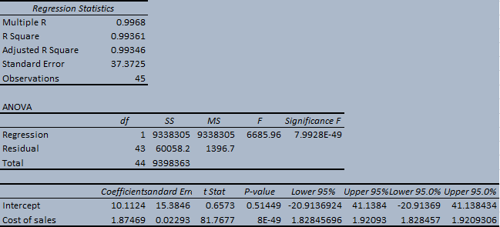

Table 4 Linear regression analysis of Cost of sales

The table 4 provides information about the relationship between the dependent variable, Sales, and the independent variable, Cost of sales. In this case, the R-squared value is 0.9936, indicating that changes in the cost of sales can account for about 99.36% of the variation in sales. The p-value for the variables (7.99276E-49) is very small, indicating that the regression model is statistically significant. The low p-value suggests that the Cost of sales variable has a significant impact on the Sales variable.

1. **Other operating income and expenses (model 2)**

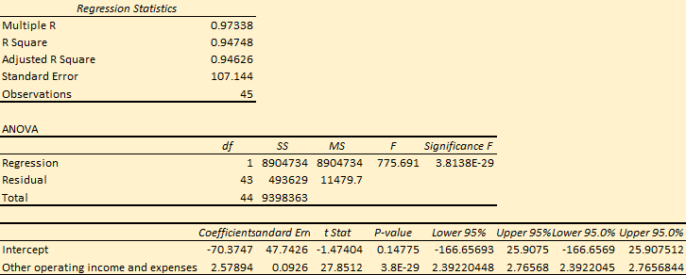

Table 5 Linear regression analysis of other operating income and expenses

This table 5 shows the regression analysis for the relationship between sales and other operating income and expenses. The R Square value (0.9475) in the table represents the coefficient of determination. It indicates that approximately 94.75% of the variance in the dependent variable (sales) can be explained by the independent variable (other operating income and expenses). The p-value associated with the regression model is expressed as 3.81377E-29. This p-value is extremely small, indicating that the regression model is statistically significant.

1. **Taxes on income (model 3)**

Table 6 Linear regression of taxes on income

According to the table 6, approximately 38.43% of the variation in sales can be attributed to changes in taxes on income since its R- square value is 0.384. This percentage suggests that the variable Tax on income has a moderate impact on sales. The higher the R-squared value, the better the model fits the data. The low p-value of 5.58963E-06 suggests that the relationship between taxes on income and sales is statistically significant, indicating that the observed relationship is unlikely to occur by chance.

1. **Net earnings (model 4)**

Table 7 Linear regression of Net earnings

The table 7 shows the relationship between net earnings and sales. In this regression analysis, the R-squared value of 0.267 suggests that around 26.7% of the variation in sales can be explained by changes in net earnings. This suggests that net earnings alone cannot fully explain the variability in sales, and other factors might also play a significant role. The small p-value of 0.000280306 indicates that the relationship between net earnings and sales is statistically significant. This suggests that the observed relationship is unlikely to occur by chance.

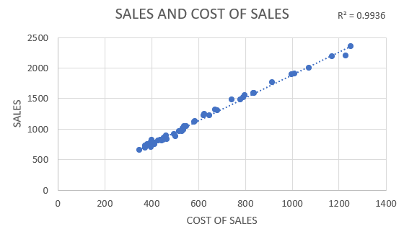

Figure 5 Scatter plot on sales and cost of sales

The regression analysis in the figure 5 reveals an incredibly robust and positive connection between sales and cost of sales, with a remarkable R² value of 0.9936. This indicates that changes in the cost of sales can almost entirely account for the variations observed in sales. As the cost of sales rises, there is a proportional increase in sales, emphasising the significant impact of cost dynamics on overall sales performance.

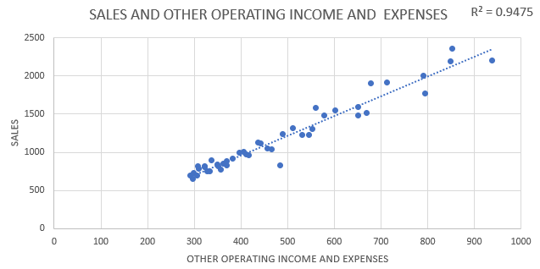

Figure 6 Scatter plot on Sales and Other operating income and expenses

The figure 6 shows the regression analysis, with an R² of 0.9475, which indicates a strong positive relationship between sales and other operating income and expenses. For every unit increase in other operating income and expenses, sales are expected to increase, suggesting a significant impact of these factors on sales performance.

**MULTIPLE REGRESSION**

Table 8 Multiple regression of Sales and its independent variables

According to the results of the multiple regression analysis in table 8, all the variation in the dependent variable (sales) can be attributed to the independent variables (cost of sales, gross profit, other operating income and expense, taxes on income, and net earnings). The model's perfect fit to the data is confirmed by the R-squared value of 1, which is 1. However, it becomes clear from looking at the coefficients that the independent variables have incredibly low values, suggesting that their association to sales has little practical impact. All of the coefficients have p-values that are almost zero, suggesting their statistical significance. Overall, the model seems to fit the data well, although the coefficients suggest that the independent factors have little effect on sales.

**DISCUSSION AND EVALUATION OF THE OUTCOME**

The given regression models provide light on the connections between sales (the dependent variable) and other independent variables. Let's review, discuss, and compare the model results considering the available data in order to pinpoint the relationships between sales and its independent factors.

Model 1 demonstrates a significant relationship between sales and the cost of sales, with the high R-squared value (0.9936) indicating that changes in the cost of sales explain about 99.36% of the sales variation.

In Model 2, the R-squared value of 0.9475 indicates that variations in other operating income and expense changes account for approximately 94.75% of the variance in sales.

Model 3 focuses on the relationship between sales and Taxes on Income. The R-squared value of 0.384 suggests that approximately 38.43% of the variation in sales can be attributed to changes in taxes on income. Lower the percentage suggest that the taxes on income have only a moderate impact on the sales.

Model 4 reveals that changes in net earnings can account for approximately 26.7% of the variation in sales, as indicated by the R-squared value of 0.267. This implies that net earnings have a moderate impact on sales.

From the four models Model 1 and Model 2 have the highest R square values of 99.36% and 94.75% so this two models will be the best choice for creating the formula to anticipate the sales.

**Hypothesis testing**

**Model 1**

**H0 =** Cost of sales has no significant effect on sales (null hypothesis)

**H1 =** Cost of sales has a significant effect on the sales (alternative hypothesis)

Since the P-value associated with the coefficient is 7.99276E-49, which is less than the conventional significance level of 0.05, we can reject the null hypothesis. This suggests that there is strong evidence to support the alternative hypothesis. In other words, there is a significant relationship between the independent variable (Cost of sales) and the dependent variable (Sales).

**Model 2**

**H0 =** Other operating income and expenses has no significant effect on sales (null hypothesis)

**H1 =** Other operating income and expenses has a significant effect on the sales (alternative hypothesis)

**Here the p-value for the coefficient of the other operating income and expenses variable is** 3.81377E-29, which is very small and is less than the conventional significance level of 0.05. Hence, we can reject the null hypothesis and accept the alternative hypothesis stating that the other operating income and expenses variable has a significant effect on sales.

**Model 3**

**H0 =** Taxes on income has no significant effect on sales (null hypothesis)

**H1=** Taxes on income has a significant effect on the sales (alternative hypothesis)

Here the P-value for the coefficient of the taxes on income variable is 5.58963E-06, which is very small and is less than the conventional significance level of 0.05. Hence, we can reject the null hypothesis and accept the alternative hypothesis stating that the taxes on income has a significant effect on the sales.

**Regression equation**

**Model 1 ( Based on cost of sales)**

**PREDICTED SALES = 10.1124 + 1.87469 * COST OF SALES**

**Model 2 ( Based on other operating income and expenses)**

**PREDICTED SALES = -70.3747 + 2.57894 * OTHER OPERATING INCOME AND EXPENSES**

Figure 7 Actual sales vs Predicted sales based on the cost of sales

The figure 7 represents actual and predicted sales in millions of euros based on the cost of sales (independent variable).

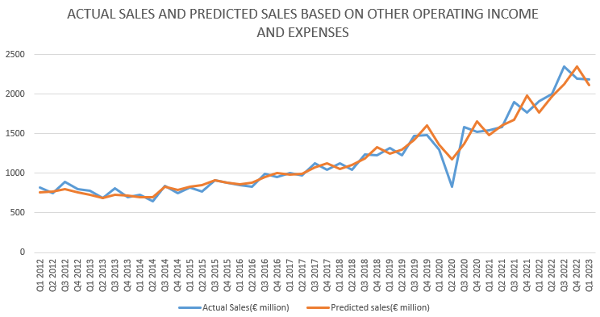

Figure 8 Actual sales vs predicted sales based on other operating income and expenses

The figure 8 demonstrates the actual and the predicted sales based on other operating income and expenses (independent variable).

**CONCLUSION AND RECOMMENDATIONS**

The financial and marketing data of the Puma Se was collected to perform the regression to find whether the sales have any relationship with its independent variable. Through the regression analysis, we came to the conclusion that all the independent variables have a significant relationship with their dependent variables. Out of all the four variables, the cost of sales and the other operating income and expenses have the highest correlation in order to predict future revenue since their R square values are very high.

**Recommendation**

Following recommendations can be adopted by the puma inorder to increase its sales

**Product diversification**

Puma can expand its product range based on market research to cater to diverse customer preferences. Collaborate with influencers and designers for limited-edition collections and innovate to meet emerging trends.

**Enhance the brand visibility and marketing efforts.**

Puma should have to Invest in targeted marketing campaigns across social media, digital advertising, and influencer partnerships to enhance brand visibility. They also should have to Create captivating content that showcases the unique features of Puma products to effectively engage customers.

**Strengthen e-commerce capabilities.**

The company should optimise the e-commerce platform for a better user experience, including improved product listings and personalised recommendations. They should have to implement tailored digital marketing strategies to drive traffic and increase online sales.

**Collaborations and partnerships**

**The partnership of the companies with influencers like athletes and celebrities will help to improve the brand visibility of the company, thereby increasing its sales.**

**REFERENCES**

Valades, B. (2023, June 15). *What is Puma’s marketing strategy?: Blucactus Agency*. BluCactus Digital Marketing. <https://blucactus.blue/what-is-pumas-marketing-strategy/>

Rhee, J. and Johnson, K.K.P. (2021) ‘Brand repositioning within the fashion industry’, *Fashion Business Cases*, pp. 92–96. doi:10.5040/9781501362989.ch-014.

*Puma - Our Mission*. PUMA SE. (n.d.). <https://about.puma.com/en/this-is-puma/our-mission>

Smith, P. (2023a) *Sportswear: Largest companies by revenue 2022*, *Statista*. Available at: <https://www.statista.com/statistics/900271/leading-sportswear-and-performance-wear-companies-by-sales-worldwide/>

Tighe, D. (2023) *Puma: Global revenue 2022*, *Statista*. Available at: <https://www.statista.com/statistics/412797/puma-global-revenue/>

Bangdiwala, S. I. (2018). Regression: Simple linear. International Journal of Injury Control and Safety Promotion, 25(1), 113-115. <https://doi.org/10.1080/17457300.2018.1426702>

InvestingPro. (n.d.). <https://www.investing.com/pro/XTRA:PUMG/financials/income_statement?entry=invpro_banner_financial_statements>

*Financial reports*. PUMA SE. (n.d.-a). <https://about.puma.com/en/investor-relations/financial-reports>

**APPENDIX**

<https://docs.google.com/spreadsheets/d/1LFL_kFs7JPs5JmLe60zJCdJthD5EhUpb/edit?usp=sharing&ouid=105669711973137286316&rtpof=true&sd=true>